第六章

6.1.2

#include<iostream>

using namespace std;

class student

{

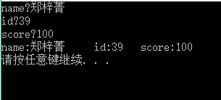public:

char name[20];

unsigned int id;

double score;

void input()

{

cout << "name?";

cin >> name;

cout << "id?";

cin >> id;

cout << "score?";

cin >> score;

}

void output()

{

cout << "name:" << name << "\tid:" << id << "\tscore:" << score << endl;

}

};

int main()

{

class student stu;

student s ;

s.input();

s.output();

}

6.综.1

#include<iostream>

using namespace std;

class Book

{

public:

char bookname[20];

double price;

int number;

void display()

{

cout << "bookname:" << bookname << "\tprice:" << price << "\tnumber:" << number << "\n";

}

void borrow()

{

number -= 1;

display();

}

void restore()

{

number += 1;

display();

}

void input()

{

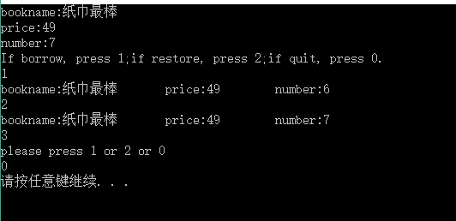 cout << "bookname:";

cin >> bookname;

cout << "price:";

cin >> price;

cout << "number:";

cin >> number;

}

};

void main()

{

class Book b;

b.input();

cout << "If borrow, press 1;if restore, press 2;if quit, press 0.\n";

for (int i = 1; i != 0;)

{

cin >> i;

switch (i)

{

case 1:b.borrow(); break;

case 2:b.restore(); break;

case 0:break;

default:cout << "please press 1 or 2 or 0\n"; break;

}

}

}

6.综.3

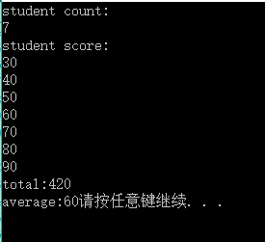#include<iostream>

using namespace std;

class student

{

static double total;

static int count;

public:

double score[10];

void scoretotalcount()

{

cout << "student count:\n";

cin >> count;

cout << "student score:\n";

for (int i = 0; i < count;i++)

{

cin >> score[i];

}

for (int j = 0; j < count;j++)

{

total = score[j] + total;

}

}

void sum()

{

cout << "total:" << total << "\n";

}

void average()

{

cout << "average:" << (total / count);

}

};

double student::total = 0;

int student::count = 0;

int main()

{

class student stu;

stu.scoretotalcount();

stu.sum();

stu.average();

}